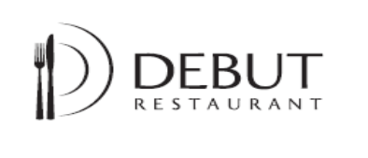


Tuesday 14th January 2025
Friday 14th February 2025

2 Course £16.50
3 Course £18.50

Starter
Debut smoked hot smoked salmon, burnt cauliflower, blini, cucumber and horseradish.
Caramelised onion and vegan feta tart, endive and frisée salad.

Mains

Slow roasted pork belly, sausage and apple, mustard mash, glazed carrot.

Gnocchi, mushroom velouté ,wild mushrooms, chestnuts , black cabbage

Dessert

Choux bun, chocolate sauce, ice cream

Warm sticky ginger pudding, sticky toffee sauce.

Coffee or tea

Food allergies and Intolerances. If you have any concerns regarding your food order, please speak to the restaurant supervisor who will be happy to help.

We reserve the right to make any changes to the above, resulting in changes from
curriculum demands.
(01603) 773227
Debut website: https://www.ccn.ac.uk/debut/
Like us on Facebook: The Debut Restaurant
Instagram: @Debutrestaurant

